SYSADD1/SYSADD2

2nd TERM, AY 2017-2018

Bonifacio Global City (BGC) Bus Passenger Information System:

Bus Tap

Submitted to:

MS. RHEA-LUZ VALBUENA

MR. MANUEL SEBASTIAN SANCHEZ

Submitted by:

ALCARAZ, ANNA LYNN C.

ANGOT, SAMMY BOY M.

BESMANO, JUSTIN V.

BRIOSO, JOB G.

Submitted on:

JANUARY 5, 2018

# Use Case Diagram

# Full Use Case Description

|  |  |  |
| --- | --- | --- |
| Use Case Name: | **Login (Passenger)** | |
| Scenario: | **Passenger logs in to their Bus Tap account.** | |
| Triggering Event: | **Passenger entered their login details on the login page of the app.** | |
| Brief Description: | **When passenger logs in to their account, the system validates that the login details entered by the passenger matches the login details of an existing Bus Tap account.** | |
| Actors: | **Passenger** | |
| Related Use Case: | **Login (Employee), Login (Manager)** | |
| Stakeholders: | **Passenger – provides the login details** | |
| Preconditions: | **Passenger must have an existing Bus Tap account** | |
| Postconditions: | **Passenger is logged in.** | |
| Flow of Activities: | Actor | System |
| 1. **Passenger requests the login page of the app.** 2. **Passenger enters the registered email address and corresponding password.** | * 1. **System displays the login page.**   2. **Validate data input**   3. **Match email address and password to an existing account**   4. **Log in passenger**   5. **Display passenger information** |
| Exception Conditions: | 1. **If email address entered does not match any existing accounts, redirect to sign-up interface or forgot username interface.** 2. **If password entered does not match the email address, redirect to forgot password interface.** 3. **Users are only given 10 chances to enter their correct login details at a time.** | |

|  |  |  |
| --- | --- | --- |
| Use Case Name: | **Reserve seat** | |
| Scenario: | **Passenger reserves a seat on a BGC Bus.** | |
| Triggering Event: | **Passenger entered travel details on the seat reservation page of the app.** | |
| Brief Description: | **When passenger wants to reserve a seat on the BGC Bus, the system displays the seats available on the selected schedule. Passenger selects an available seat, and the bus driver reserves the seat on the bus for the passenger.** | |
| Actors: | **Passenger**  **Driver** | |
| Related Use Case: |  | |
| Stakeholders: | **Passenger – provides date and time of travel, bus stop; selects the bus schedule; selects the bus seat**  **Driver – reserves the bus seat** | |
| Preconditions: | **Passenger must be logged in to their Bus Tap account.** | |
| Postconditions: | **A seat is reserved for the passenger.** | |
| Flow of Activities: | Actor | System |
| 1. **Passenger requests the seat reservation page of the app.** 2. **Passenger enters the date, time, and the bus stop.** 3. **Passenger selects the bus schedule.** 4. **Passenger selects the seat to reserve.** 5. **Driver reserves the seat.** 6. **Passenger shows the reservation code to claim the reserved seat.** 7. **Driver enters the reservation code.** | * 1. **System displays the seat reservation page of the app.**   **2.1 System displays the available schedules closest to the travel details entered by the passenger.**  **3.1 System displays the seat map for the selected schedule.**   * 1. **System reserves the selected seat for the passenger.**   2. **System notifies the corresponding driver of the seat reservation.**   3. **System verifies reservation code.**   4. **System sets the reservation as claimed.** |
| Exception Conditions: |  | |

|  |  |  |
| --- | --- | --- |
| Use Case Name: | **Plan travel** | |
| Scenario: | **Passenger wants to know how to travel from one place to another in BGC using the BGC Bus.** | |
| Triggering Event: | **Passenger entered origin and destination on the plan travel page of the app.** | |
| Brief Description: | **When passenger enters an origin and destination, the system displays a detailed travel itinerary for the passenger, including the bus stop nearest to the origin, available BGC bus routes, fare, and estimated travel time.** | |
| Actors: | **Passenger** | |
| Related Use Case: |  | |
| Stakeholders: | **Passenger – provides origin and destination** | |
| Preconditions: | **The user must have an internet connection.**  **The user must allow the app to access the passenger’s location through their mobile phone.** | |
| Postconditions: | **Detailed travel itinerary must be displayed.**  **Map must display the location of the bus stop nearest to the origin.**  **Map must display the relevant BGC bus routes.**  **Estimated travel time must be displayed.**  **Fare must be displayed.** | |
| Flow of Activities: | Actor | System |
| 1. **Passenger requests the plan travel page of the app.** 2. **Passenger enters the origin and destination.** | **1.1 System displays the plan travel page of the app.**  **2.1 System checks the location of the passenger.**  **2.2 System displays the location of the bus stop nearest to the passenger’s location.**  **2.3 System displays the BGC bus routes that can take the passenger from the bus stop nearest the origin to the bus stop nearest the destination.**  **2.4 System displays the bus fare for the corresponding bus route.**  **2.5 System estimates the travel time for the trip.** |
| Exception Conditions: | 1. **Internet Connection is required.** 2. **Origin and destination entered must be within the scope of the app.** | |

|  |  |  |
| --- | --- | --- |
| Use Case Name: | **Generate bus schedules** | |
| Scenario: | **Manager should be able to generate bus schedule so that user would be able to view all bus schedules** | |
| Triggering Event: | **Viewing of travel details** | |
| Brief Description: | **The passenger should be able to view the bus schedule generated by the manager** | |
| Actors: | **Logged in Passenger Manager** | |
| Related Use Case: | **Logging of accounts** | |
| Stakeholders: | **Manager – the one who will update the bus schedules Logged passengers – the one who will view the schedules** | |
| Preconditions: | **Bus schedule data should be available Passenger should be logged in to view the details** | |
| Postconditions: | **The logged in passenger should be able to view all details regarding bus schedules** | |
| Flow of Activities: | Actor | System |
| 1. **User requests to view the bus schedules of the bus** | * 1. **System displays all the bus schedules** |
| Exception Conditions: | 1. **Bus schedule should be available, if not, the manager or administrator should provide** | |

|  |  |  |
| --- | --- | --- |
| Use Case Name: | **Locate bus** | |
| Scenario: | **Locating the bus** | |
| Triggering Event: | **Passengers wants to know the location of the bus** | |
| Brief Description: | **Passenger should successfully know the location of every bus** | |
| Actors: | **Logged in Passengers** | |
| Related Use Case: | **Log in, Plan travel** | |
| Stakeholders: | **Logged in Passengers** | |
| Preconditions: | **The bus should be available**  **Passenger should be logged in** | |
| Postconditions: | **The logged in passenger should be able to locate the bus nearest to a bus stop** | |
| Flow of Activities: | Actors | System |
| 1. **Passenger wants to know the location of the bus** | **1.1 System displays the location of the bus** |
| Exception Conditions: | 1. **If the user does not give an account, redirect it to the log in account page.** 2. **The system should be successfully able to show the location of the bus.** | |

|  |  |  |
| --- | --- | --- |
| Use Case Name: | **Check beep card balance** | |
| Scenario: | **Checking the remaining balance of user’s beep card** | |
| Triggering Event: | **Beep card balance inquiry** | |
| Brief Description: | **If a user does not know the remaining balance of their beep card, the system has the functionality to check the balance but only for NFC-enabled Android devices only.** | |
| Actors: | **Logged in Passenger** | |
| Related Use Case: |  | |
| Stakeholders: | **User – Owner of the beep card** | |
| Preconditions: | **User must have their own respective card**  **User’s phone must be NFC enable to fully use this functionality** | |
| Postconditions: | **Message will appear regarding the card’s remaining balance**  **If the remaining balance was not sufficient to ride the bus, message would appear as if the user is task to load their card**  **Save transaction** | |
| Flow of Activities: | Actor | System |
| 1. **User wants to check their card’s remaining balance** 2. **User taps the beep card into the NFC section of their phones** | * 1. **The system shall work on all NFC enabled android devices**   2. **Message will appear regarding the card’s remaining balance**   3. **If the balance is sufficient to ride the bus, system must be able to notify the user to load the card**   4. **After tapping the card, transaction should be save for history purposes** |
| Exception Conditions: | 1. **The functionality would only work on NFC enabled android devices** 2. **User must have their own beep cards** | |

|  |  |  |
| --- | --- | --- |
| Use Case Name: | **Rate and provide feedback** | |
| Scenario: | **The passenger wants to give feedback regarding the user’s trip** | |
| Triggering Event: | **User feedback and detailed itinerary** | |
| Brief Description: | **The passenger should be able to give feedback and rate regarding his/her trip** | |
| Actors: | **Logged in Passenger** | |
| Related Use Case: | **Log in** | |
| Stakeholders: | **Logged in passenger – the one who will give feedback** | |
| Preconditions: | **Users must successfully log in to their accounts** | |
| Postconditions: | **The rate and feedbacks should be able to go to the administrator’s database** | |
| Flow of Activities: | Actor | System |
| 1. **User will rate the driver and his/her overall trip** 2. **User will give feedbacks** | **1.1 Validate the credentials of the user**   * 1. **Rating page would show up**   **1.3 Allow the user to rate his/her travel**  **1.4 Save it to the system’s database**   * 1. **Validate the credentials of the user**   2. **Feedback page should show up**   3. **Allow the user to give feedback**   4. **Save the feedback of the user** |
| Exception Conditions: | **The user should be registered, if not, redirect to create account and log in page.** | |

|  |  |  |
| --- | --- | --- |
| Use Case Name: | **View congestion status.** | |
| Scenario: | **Administrator gathers data and use it for forecasting** | |
| Triggering Event: | **Generate report on passenger congestion** | |
| Brief Description: | **Forecasting the number of passengers of BGC Bus at a specified time and day. Predicting the Congestion status for knowing how many buses needs to be deployed on a given time and situation.** | |
| Actors: | **Management** | |
| Related Use Case: |  | |
| Stakeholders: | **Administrator – collects the data** | |
| Preconditions: | **Data or historical data is required** | |
| Postconditions: | **Ability to forecast and generate the result that would be given to the user.** | |
| Flow of Activities: | Actor | System |
| 1. **Data gathering – knowing the amount of passengers that BGC Bus has every day** 2. **check the congestion at different time of the day.** | **1. Generate a forecasting method and predict the congestion status for the given day. By doing so, the management would be ready for the large volume of passenger that the BGC bus have especially on holidays** |
| Exception Conditions: |  | |

# Object Diagram

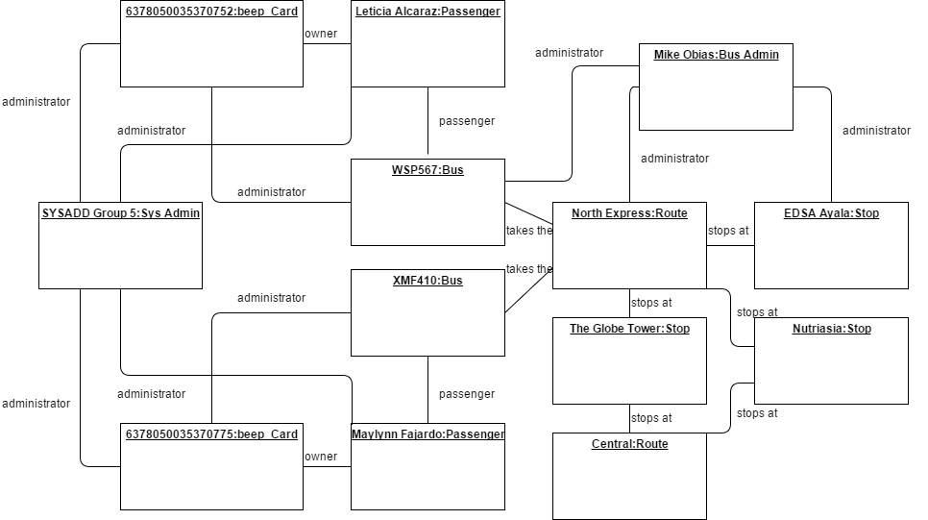

# Class Diagram

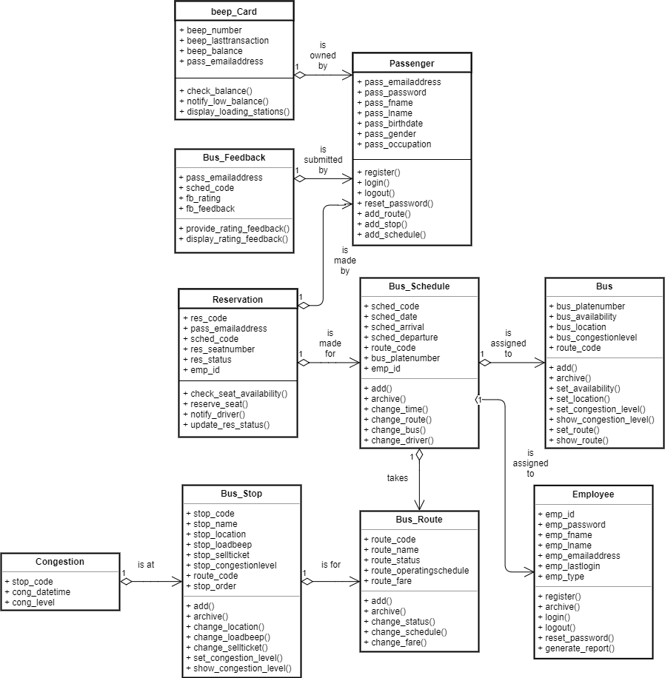

# Activity Diagram

Activity diagram for Use Case: Login

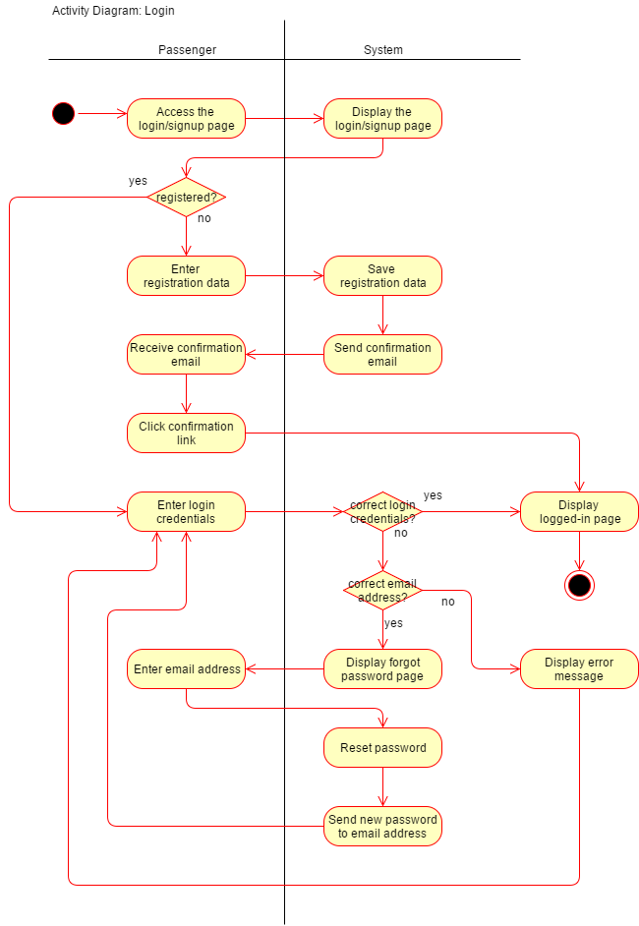

Activity diagram for Use Case: Reserve seat

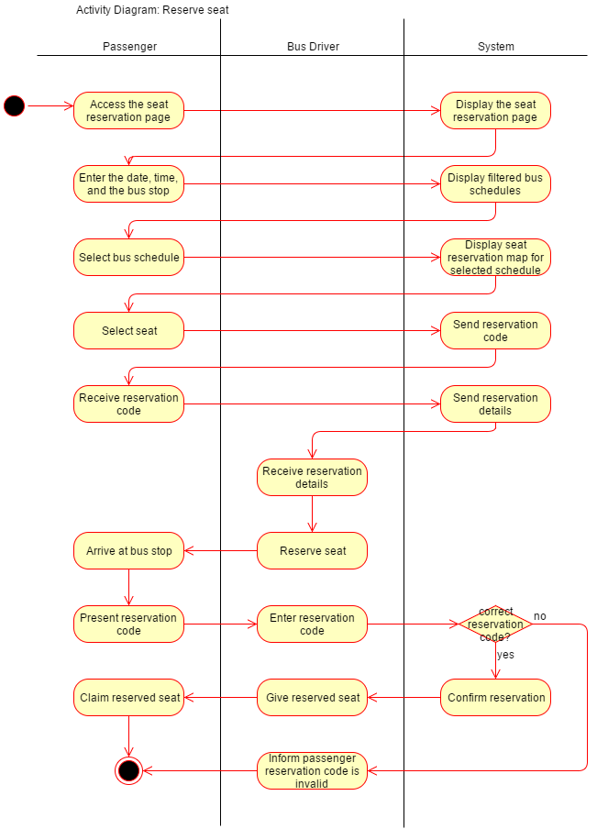

Activity diagram for Use Case: Plan travel

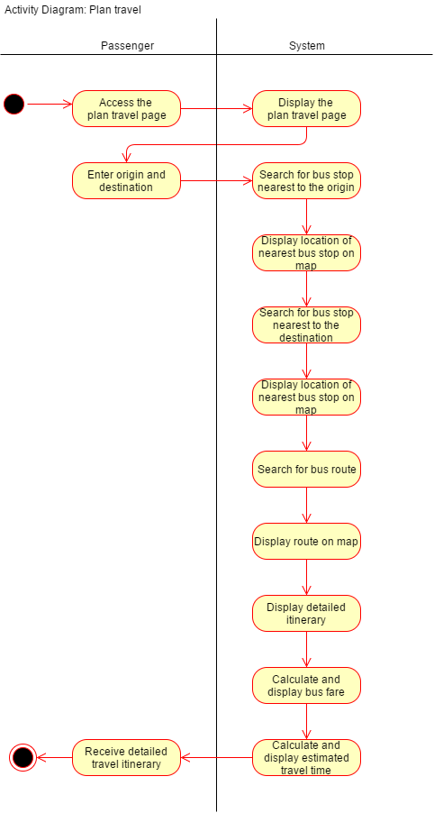

Activity diagram for Use Case: Generate bus schedules

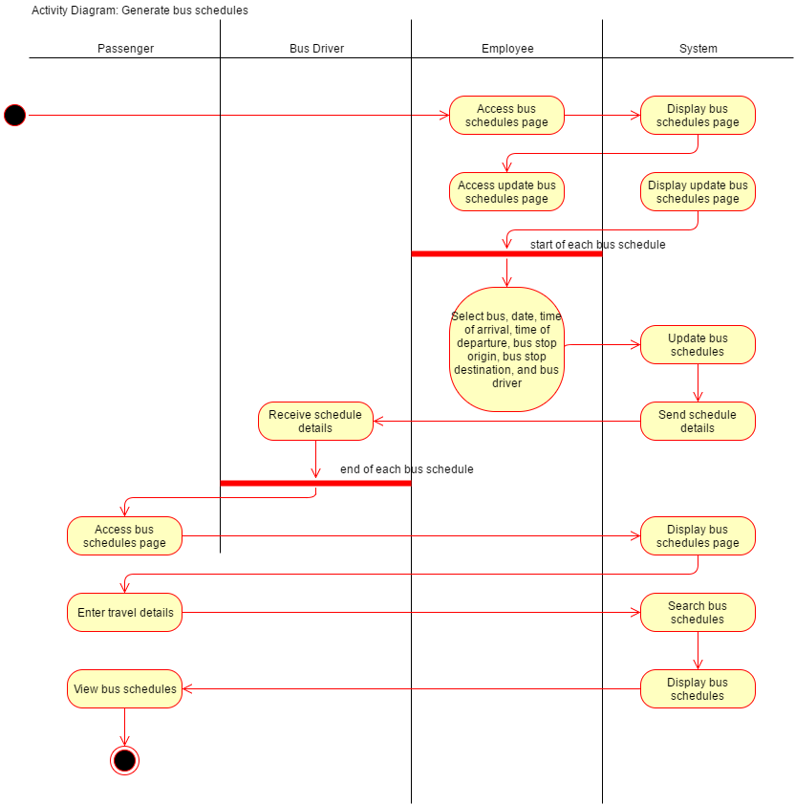

Activity diagram for Use Case: Locate bus

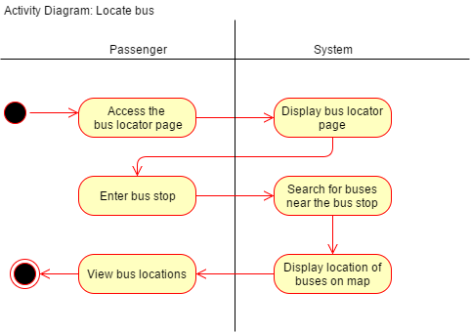

Activity diagram for Use Case: Check remaining balance

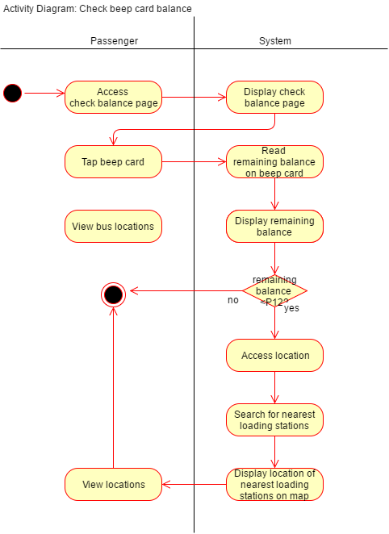

Activity diagram for Use Case: Rate and provide feedback

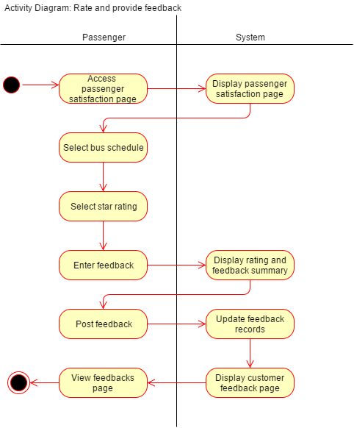

Activity diagram for Use Case: View congestion status

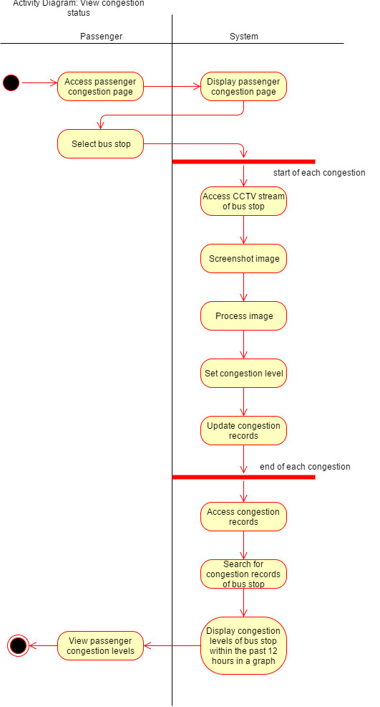

# State Machine Diagram

State Machine diagram for Object: Passenger

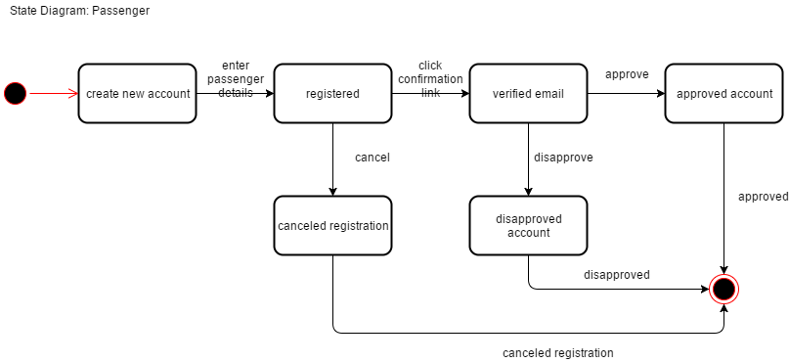

State Machine diagram for Object: Reservation

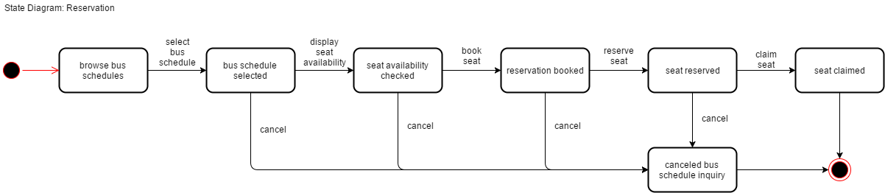

State Machine diagram for Object: Feedback

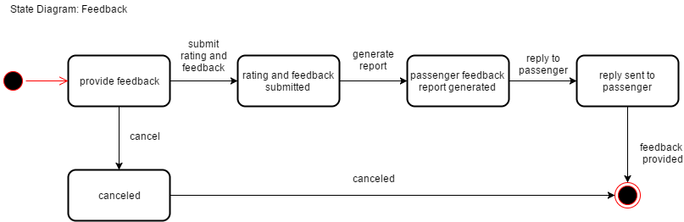

State Machine diagram for Object: Bus

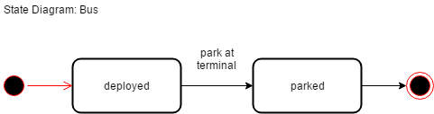

State Machine diagram for Object: Bus Schedule

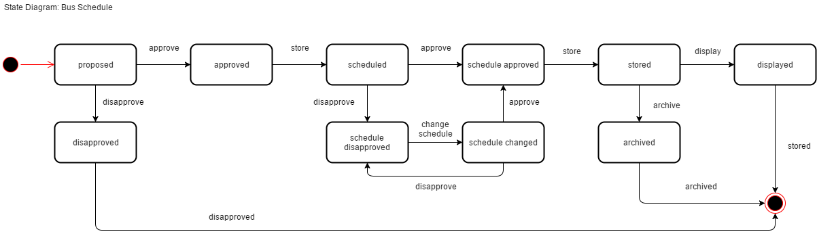

State Machine diagram for Object: Employee

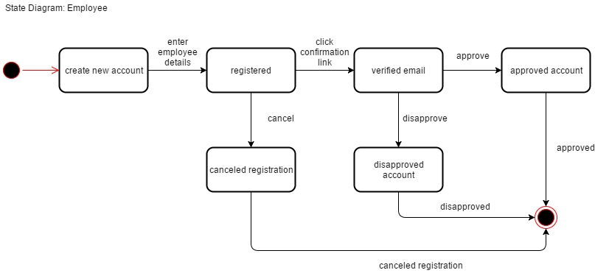

State Machine diagram for Object: Bus Route

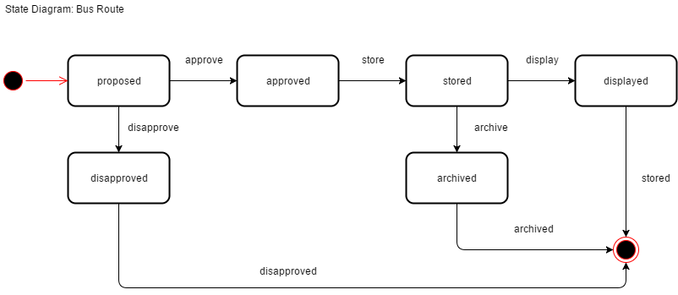

State Machine diagram for Object: Bus Stop

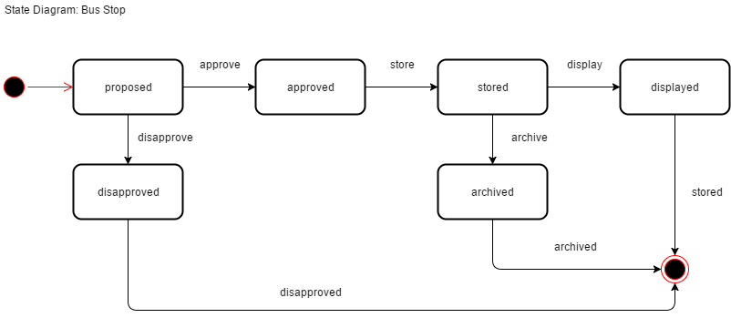

# Timing Diagram

Timing diagram for Object: Beep Card

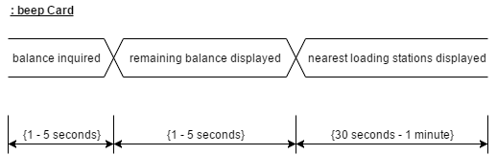

Timing diagram for Object: Passenger

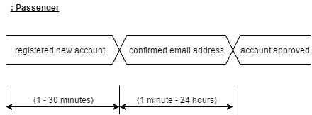

Timing diagram for Object: Reservation

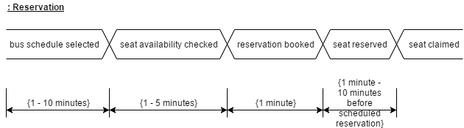

Timing diagram for Object: Feedback

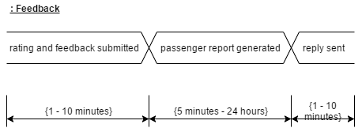

Timing diagram for Object: Bus

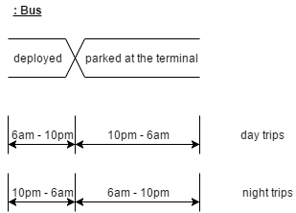

Timing diagram for Object: Employee

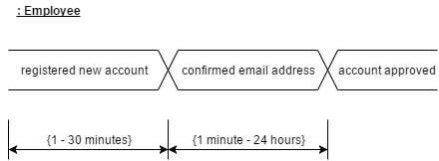

Timing diagram for Object: Congestion

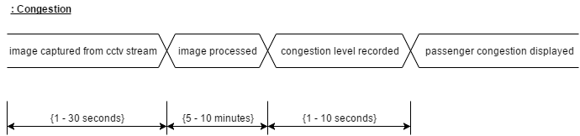

# Communication Diagram

Communication diagram for Use Case: Reserve seat

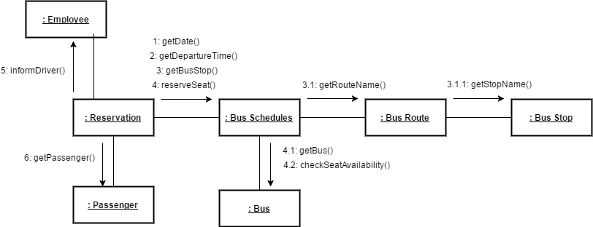

Communication diagram for Use Case: Plan travel

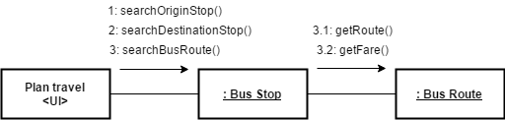

Communication diagram for Use Case: Display bus schedules

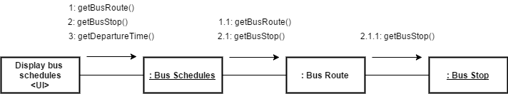

# Sequence Diagram

Sequence diagram for Use Case: Login

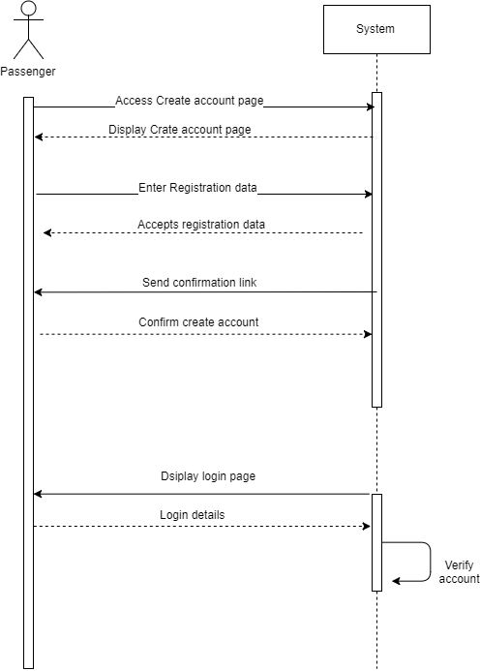

Sequence diagram for Use Case: Reserve seat

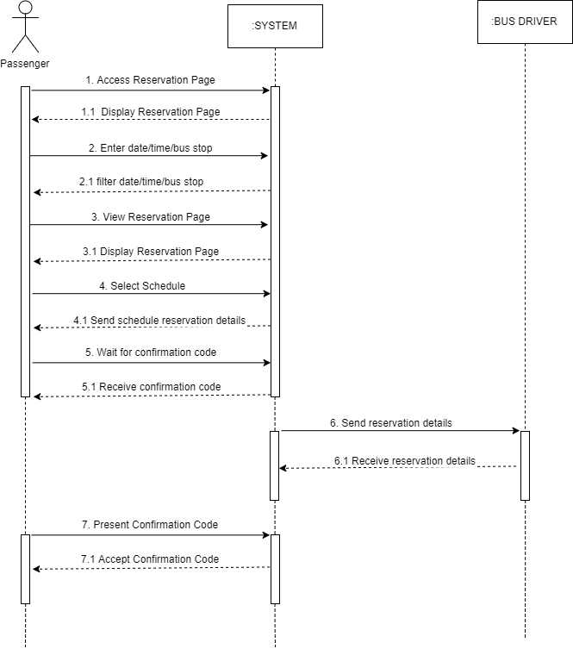

Sequence diagram for Use Case: Plan travel

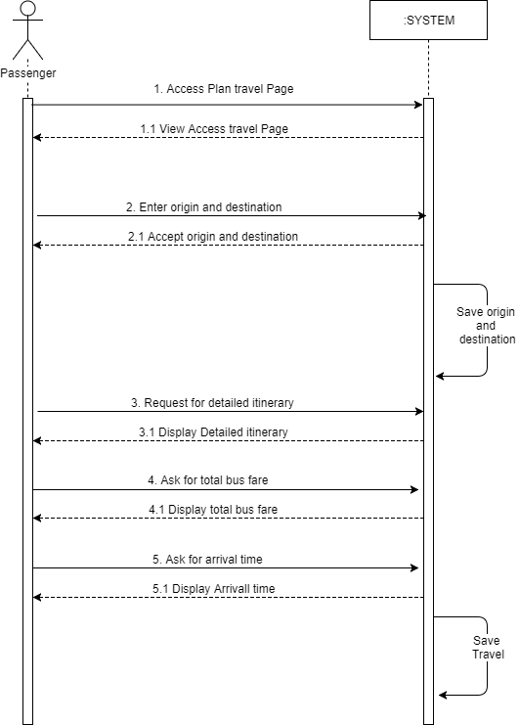

Sequence diagram for Use Case: Generate bus schedules (employee)

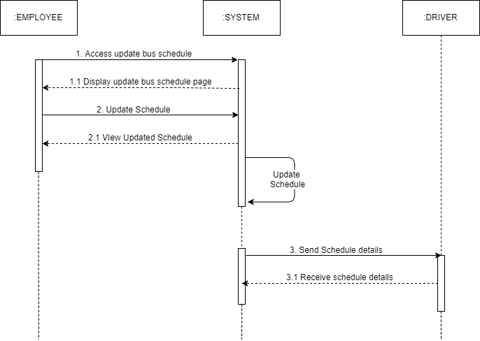

Sequence diagram for Use Case: Generate bus schedules (passenger)

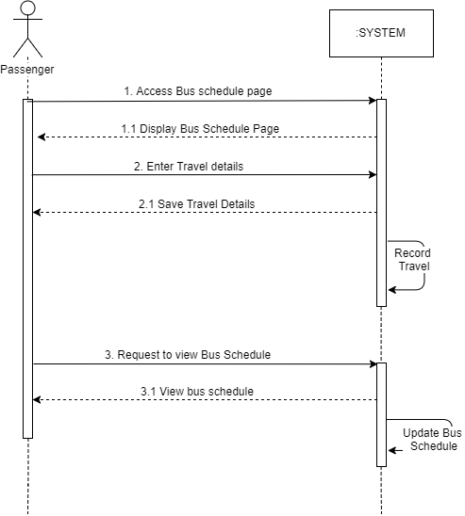

Sequence diagram for Use Case: Locate bus

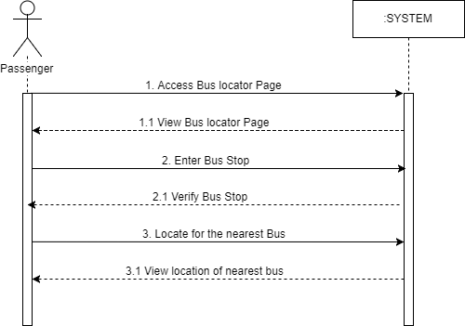

Sequence diagram for Use Case: Check remaining balance

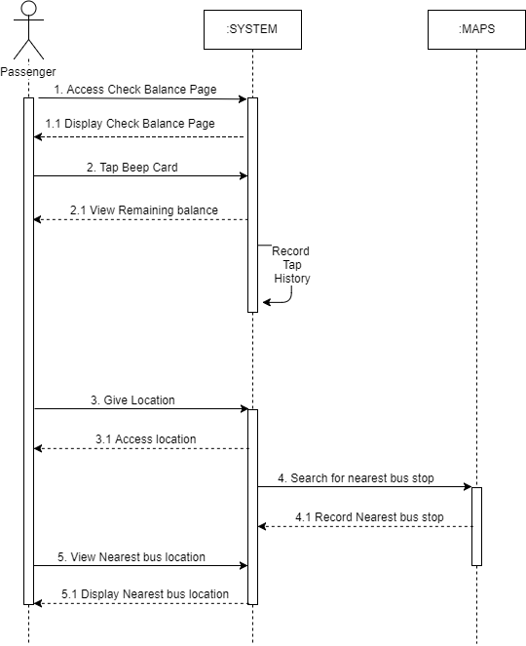

Sequence diagram for Use Case: Rate and provide feedback

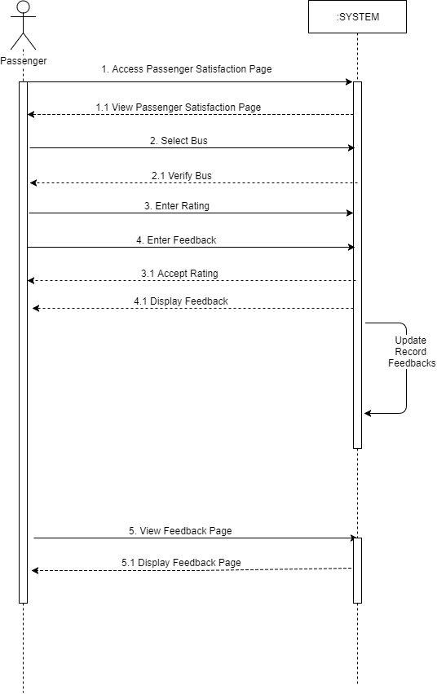

Sequence diagram for Use Case: View congestion status

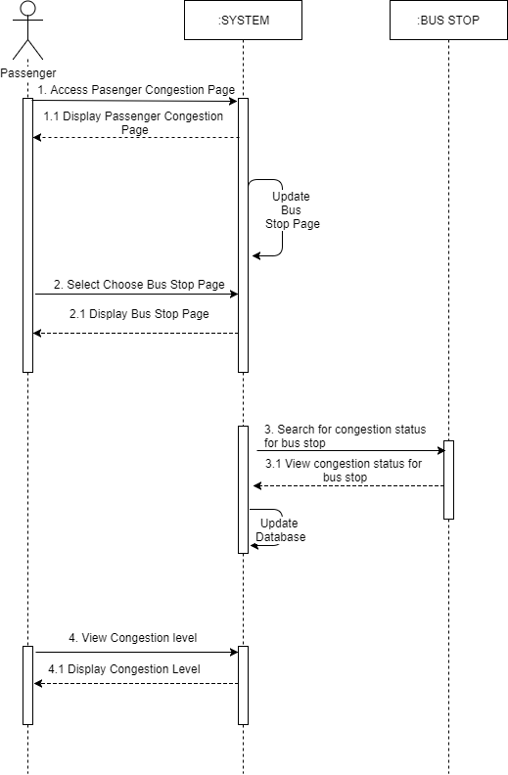

Sequence diagram for Use Case: Generate report

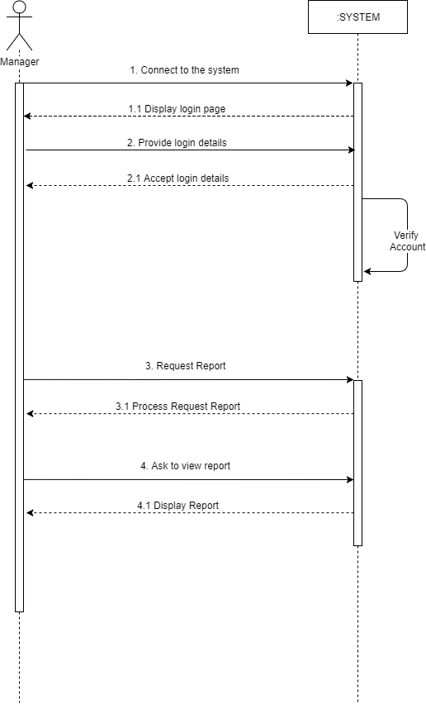

# Package Diagram

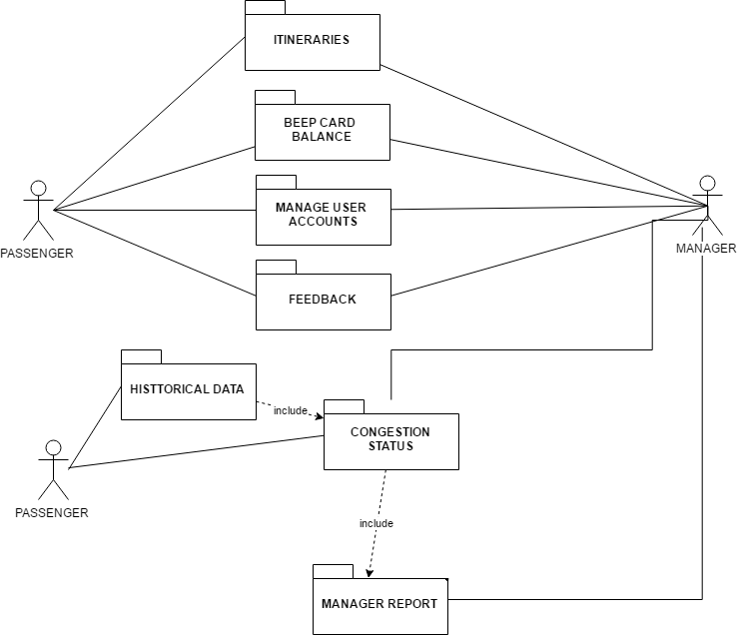

# Component Diagram

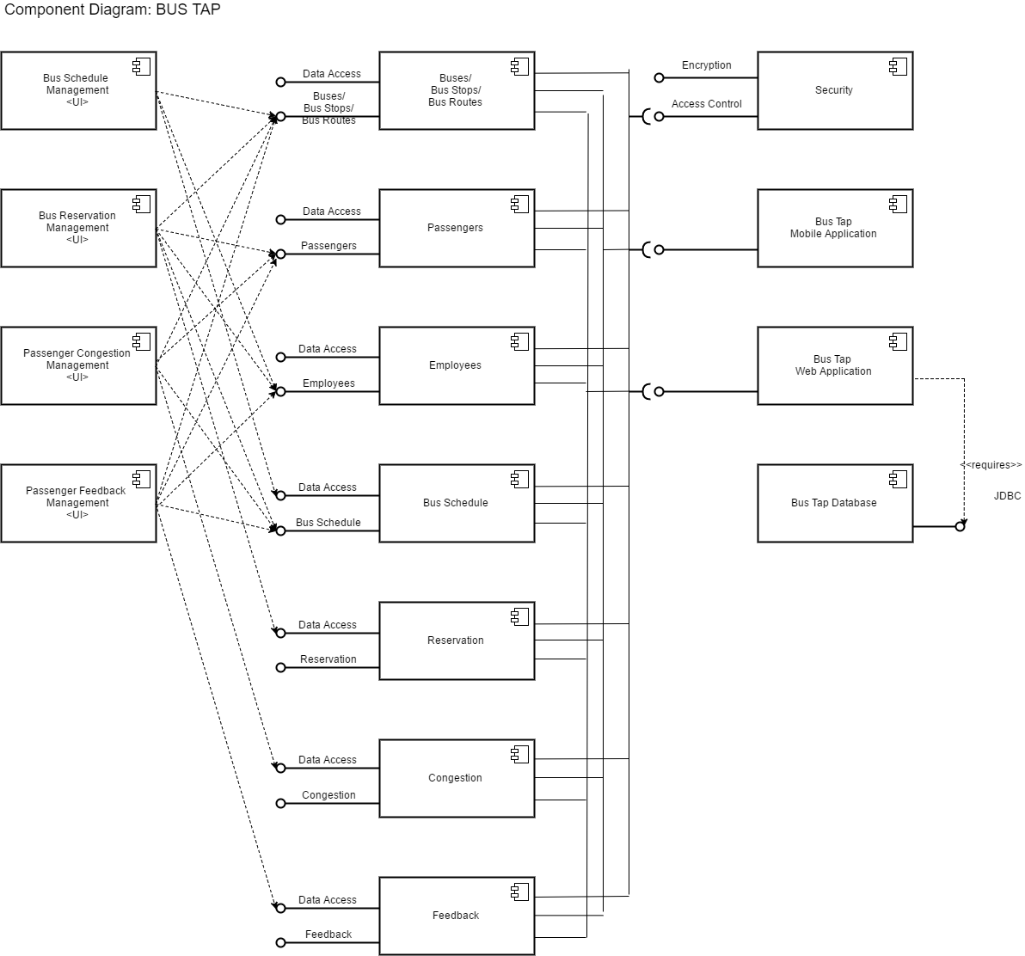

# Deployment Diagram

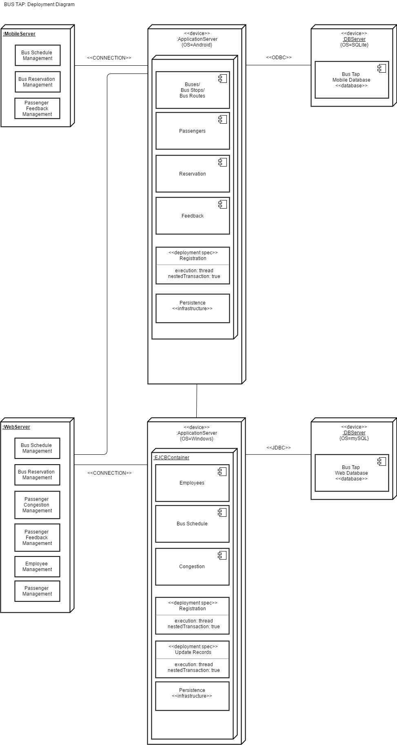

# Composite Structure Diagram

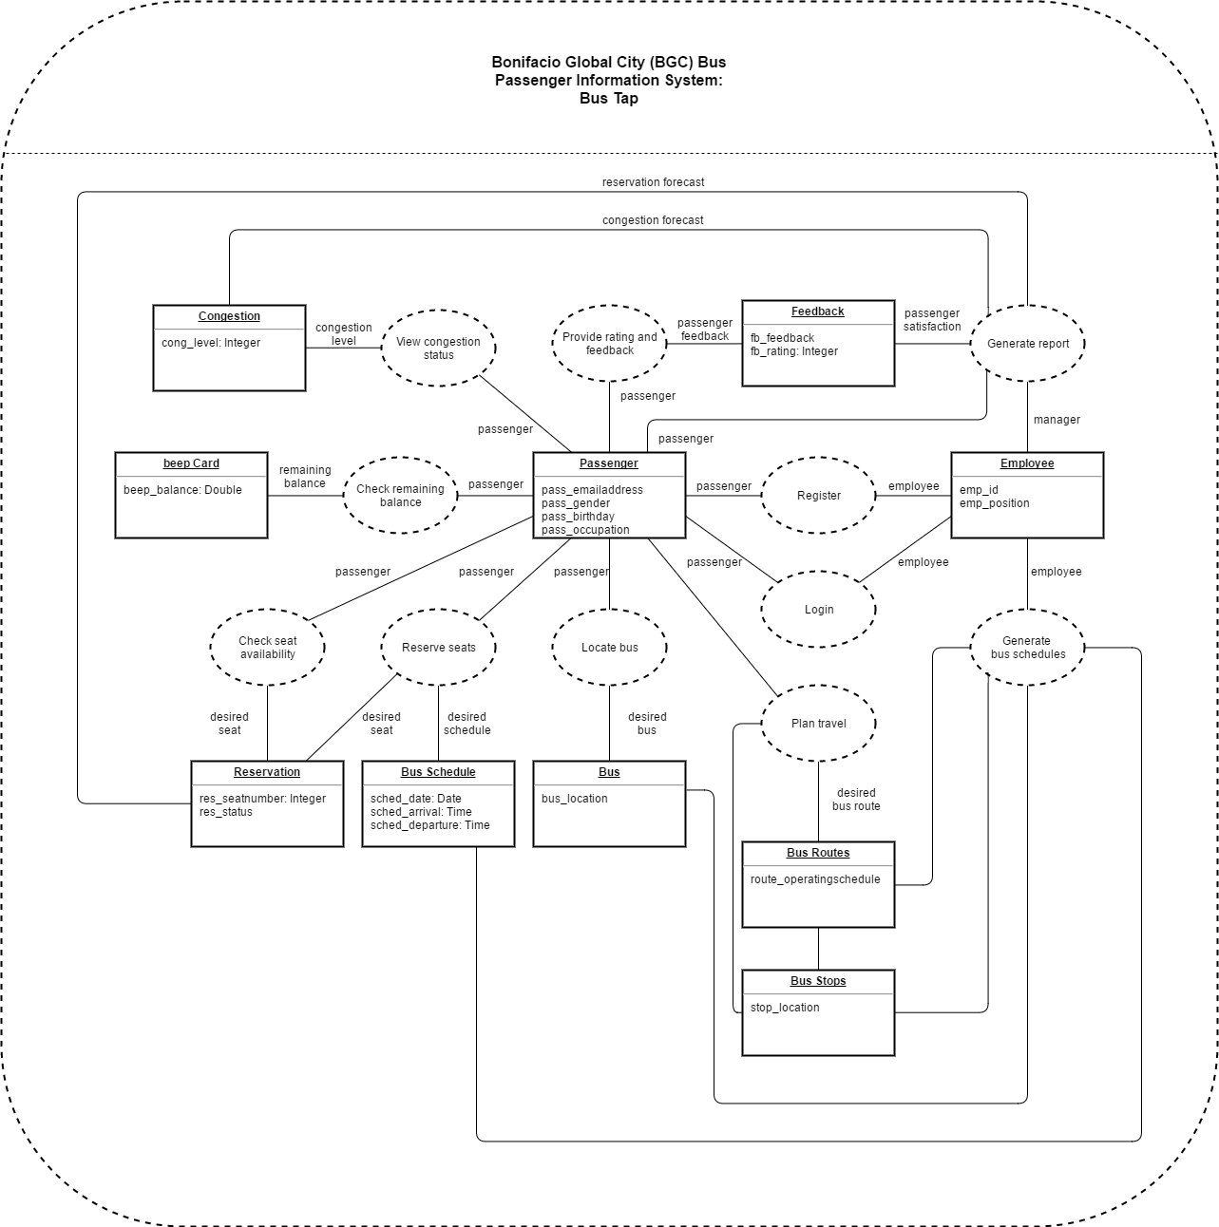

# Interaction Overview Diagram

